IDEATION PHASE
DEFINE THE PROBLEM STATEMENTS
Date
Team ID | SWTID-2026-3317 _______________
Project Name | AI FAQ Assistant
Maximum Marks | 2 Marks

Customer Problem Statement
Create a problem statement to understand your customer's point of view. The problem statements below focus on the challenges faced by users and support staff when accessing and providing answers to frequently asked questions.
Reference: Miro Customer Problem Statement Template

Problem Statement (PS)
I am (Customer) | I am a student / user
I’m trying to | I’m trying to get quick answers to frequently asked questions
But | But I have to search through different sources or wait for assistance
Because | Because the information is not always available in one place
Which makes me feel | Which makes me feel frustrated and wastes my time

I am (Customer) | I am an administrator / support staff
I’m trying to | I’m trying to provide accurate answers to repeated questions
But | But I have to answer the same questions many times
Because | Because there is no centralized intelligent FAQ system
Which makes me feel | Which makes me feel that support work is repetitive and time-consuming

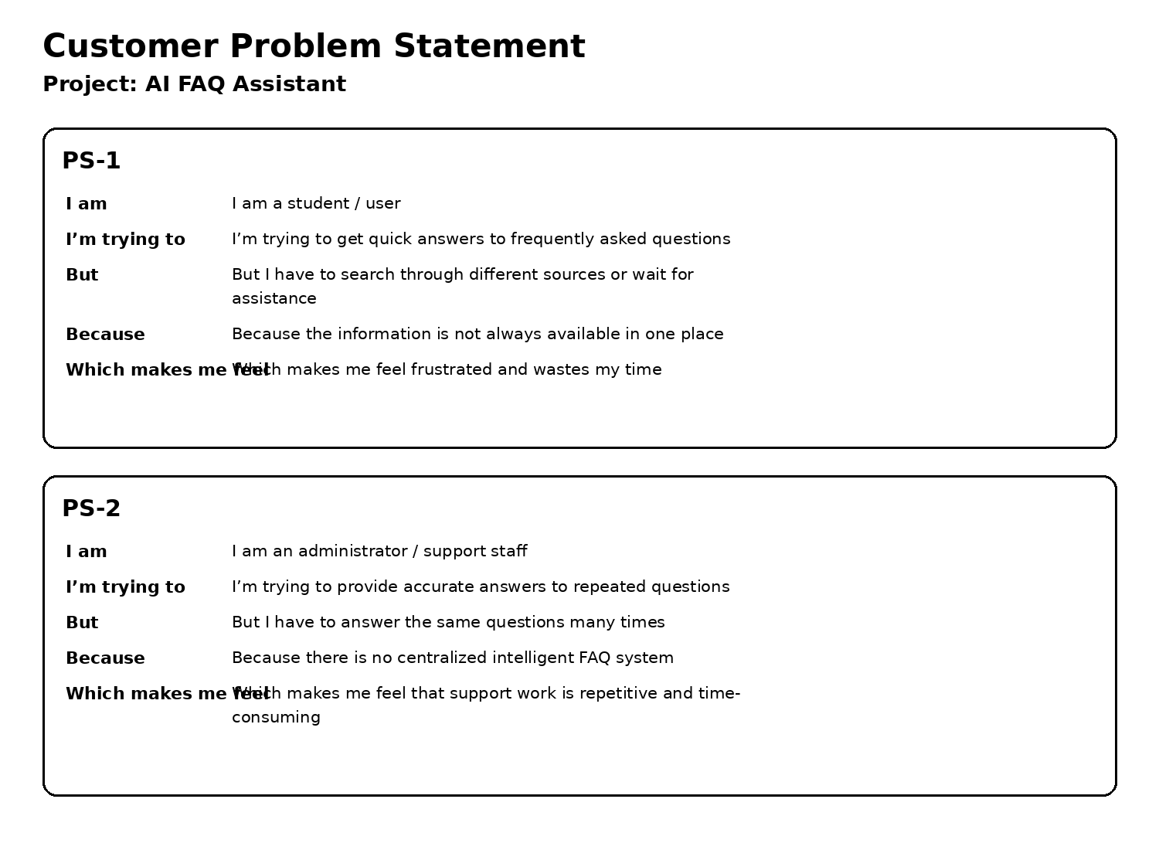

Final Problem Focus
Users need a centralized AI-powered FAQ Assistant that can provide quick, relevant and easy-to-understand answers to frequently asked questions, while reducing repetitive support work.

